TRƯỜNG THCS NGUYỄN VĂN CỪ

ĐỀ CƯƠNG ÔN TẬP MÔN ANH VĂN 7
UNIT 7: TRAFFIC

A. PHONETICS

I. Write the sound /e/ or /eI/ of the underlined letter(s)

1. train / |  |  |  |  |  | / |  | 6. left / / |  |  |  |  |  | 11. sail / / |  |  |  |  |  |  |  | 16. healthy / |  |  |  | /
2. seatbelt / |  |  |  |  |  |  | / | 7. ahead / |  |  |  | / |  | 12. safety / |  |  |  |  |  | / |  | 17. plane / |  |  |  | /
3. mistake / |  |  |  |  |  |  | / | 8. station / |  |  |  | / |  | 13. railway / |  |  |  |  |  | / |  | 18. great / |  |  |  | /
4. helmet / |  |  |  |  |  |  | / | 9. helicopter / |  |  |  |  | / | 14. brake / |  |  |  |  |  | / |  | 19. record / |  |  |  | /
5. way / |  |  |  |  |  | / |  | 10. pavement / |  |  |  |  | / | 15. pedestrian / / |  |  |  |  |  |  |  | 20. said / /

- Underline the words having the sound /e/ and circle the words having the sound /eI/ in the sentences below. Then read the sentences aloud.

- Which one is better, train or plane?

- Great! This is the best way to the railway station.

- Let’s take a break and have some fresh bread!

- For your safety, you must obey the traffic rules when driving.

- Jane was standing on the pavement waving her friends.

- The wet weather is expected to continue in central valley.

- I sat waiting patiently for the wedding to end.

III. Find the word which has the different sound in the underlined part.

1. a. break |  |  |  |  | b. bread |  |  |  |  | c. instead
2. a. lane |  |  |  |  | b. stay |  |  |  |  | c. traffic
3. a. record |  |  |  |  | b. vehicle |  |  |  |  | c. lesson
4. a. jam |  |  |  |  | b. narrow |  |  |  |  | c. carry
5. a. means |  |  |  |  | b. great |  |  |  |  | c. seatbelt

B. VOCABULARY AND GRAMMAR

I. Write the means of transport under the correct pictures

- health

d. wait. d.zebra d.danger d.teacher

bike | plane | truck | train | ship | motorbike
car | boat | bus | subway | helicopter |  | van
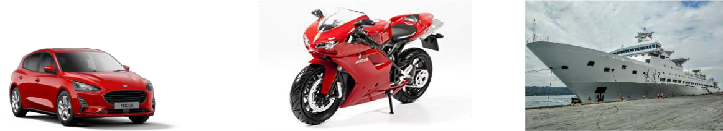

1………………… 2………………. 3……………….
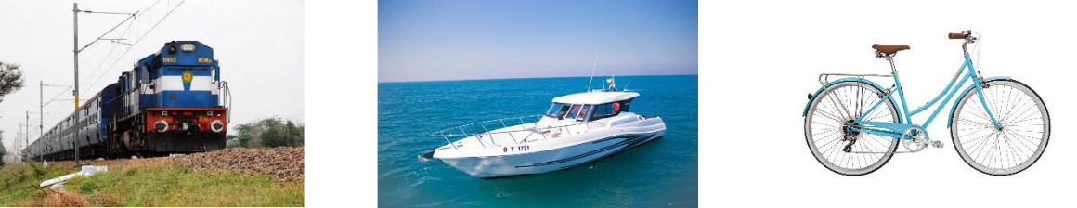

4…………………. 5………………… 6…………………
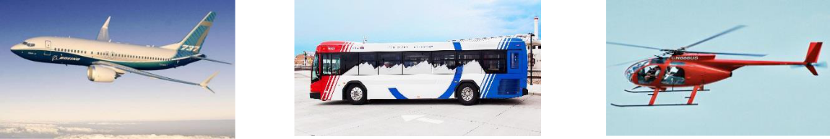

7……………….. 8………………….. 9……………….
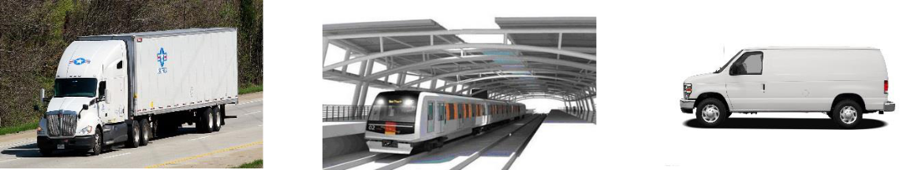

10……………… 11……………….. 12………………..

II. Match the words in part 1 with definitions.

1. | A large, heavy vehicle with wheels. It is used for carrying goods. | __________
2. | A vehicle with two wheels that you ride by pushing its pedals with your feet | __________
3. | A vehicle that has two wheels and an engine. | __________
4. | A large machine that runs along a railway line. It can carry many people. | __________
5. | A very large boat used for carrying people or goods across the sea. | __________
6. | A aircraft with large metal blades on top that spin and lift it into the air. | __________
7. | A vehicle that flies in the sky and has wings and one or more engine. | __________
8. | A large vehicle with lots of seats. It carries passengers from one place to | __________
another.
9. | A small vehicle that travels on water, moved by oars, sails or a motor. | __________
10. A railway system that runs under the ground below a big city. |  | __________

III. Complete the sentences with the correct tense or form of the verbs from the box.

ride drive fly sail cycle reverse get on get off

- My uncle used to be a pilot. He ___________ helicopters.

- __________ a number 73 bus. That will take you to Islington High Street.

- He ________into a lamppost and damaged the back of the car.

- When being stuck in a traffic jam, some people __________ their motorbikes on the pavement.

- The old man got into a Rolls Royce and __________ away.

- I will get myself a little boat and ________ it around the world.

- When we reach the next stop, we’ll ____________.

- In the afternoon, Mai usually _____________ round the lake near her house.

IV. Fill in the each gap with an expression in the box.

plane tickets zebra crossings driving licence traffic jam speed limit

cycle helmet means of transport road safety railway station road sign

1. Be careful! The _____________ says “No U-Turn”.

- You ran through the stop sign. May I see your ________________, please?

- It is the law that motorists give way to pedestrians at _______________.

- You can book your _______________ online, by phone, or through a travel agent.

- Slow down – the _______________ on this road is 60 mph.

- We were stuck in a _______________ on the freeway for two hours.

- When we got to the _______________ the train had left.

- What _______________ did they use at that time? – horses

- _______________is taught to young children to avoid road accidents.

- You should wear a _______________ when riding a bike.

V. What do these signs mean? Choose the correct answers.
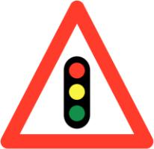

 | a. Traffic lights ahead | 2. | a. Walking only
 | b. Stop at the traffic lights | 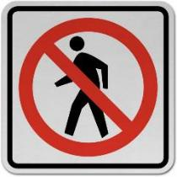 | b. No crossing the street
 | c. No traffic lights on this |  | c. No pedestrians.
1. | road
3. | a. Two-way traffic ahead | 4. | a. No playing in the street
 | b. One-way road |  | b. No parking allowed
 | c. Road narrows |  | c. No pedestrian traffic
5. | a. Trash removal nearby | 6. | a. No entry for motor
 | b. workers on this road |  | vehicles
 | c. road works ahead |  | b. Give way to traffic
 |  |  | c. Only cars and
 |  |  | motorbikes allowed
7. | a. School crossing ahead | 8 | a. No left turn
 | b. Pedestrians only |  | b. U-turn is prohibited
 | c. Crosswalk ahead |  | c. U-turn allowed
9. | a. Slippery road | 10. | a. Stop here
 | b. Oil on road |  | b. One lane traffic
 | c. Road curves ahead |  | c. No entry
11. | a. All vehicles turn back | 12. | a. No right turn
 | b. Roudabout ahead |  | b. Go straight ahead on
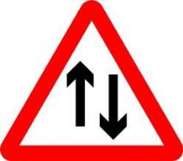
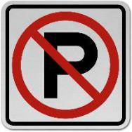
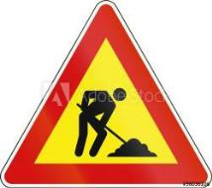
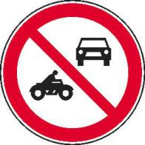
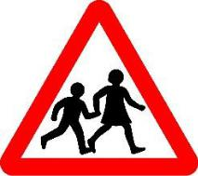
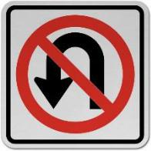
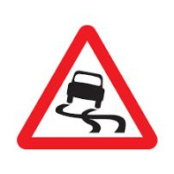
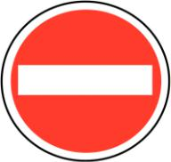
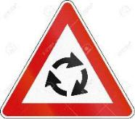
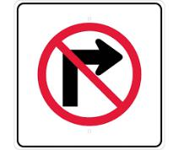
red
c. Turn left only

c. No turn right on red

VI. Complete the sentences

with can, must or mustn’t

1. | You _____________ park here.
2. | You _____________ turn left.
3. | You _____________ ride your motorbike on this road.
4. | You _____________ stop.
5. | You _____________ drive more than 50 km/h.
6. | Only cyclists _____________ enter this lane.
7. | You _____________ go ahead or turn right.
8. | You _____________ make a U-Turn here.
9. | You _____________ give way.
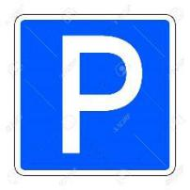
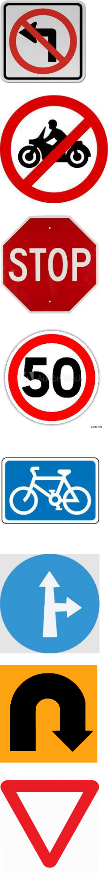

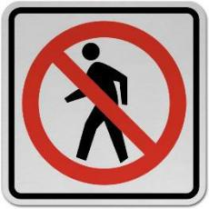
10. Pedestrians _____________ enter.

VII. Complete the sentences with used to or didn’t use to and the verbs in the box.

play wash be eat like travel live work read get up

- I _____________ in the countryside when I was a child.

- My mother _____________ coffee but now she loves it.

- Julian _____________ much, but Harry Potter changed his attitude.

- Dave _____________ in a football team but now he plays basketball.

- The children _____________early because they had to get to school at 7 o’clock.

- The shop _____________ so crowded as it is nowadays.

- In those days, people _____________ all their clothes by hand.

- I _____________ in a restaurant before I went to college.

- People _____________ so much junk food, their diet was healthier.

- When my father was young, he _____________ abroad so much.

VIII. Write sentences, using the prompts and then correct form of used to.

- We/ live in a flat when I was a child.

_________________________________________________________________

- People/ not have/ mobile phones 20 years ago.

_________________________________________________________________

- Jim/ go/ swimming every weekend?

_________________________________________________________________

- My father/ smoke/ but he gave up five years ago.

_________________________________________________________________

- Lily/ not cook/ much, but now she makes dinner every day.

_________________________________________________________________

- There/ be/ a supermarket on the corner?

_________________________________________________________________

- People/ not buy/ so much stuff as they do today.

_________________________________________________________________

- You/ play football or basketball at school?

_________________________________________________________________

- I/ go/ to bed very late but not anymore!

_________________________________________________________________

- Which TV programme/ you/ watch/ most/ when you were little?

_________________________________________________________________

IX. Complete the dialogue with the correct form of used to

John:

Sally:

John:

Sally:

John:

Sally:

What (1) _____________ (you/ be) like when you were a child?

I (2) _____________ (wear) very thick glasses, and I(3)__________ (be) quite

short. To be honest, I (4) _____________ (not like) myself very much.

What (5) _____________ (you/do) for fun?

Oh, we (6) _____________ (not have) phones or technology of any kind and

the streets (7) _____________ (be) safer than now, so we (8) _____________

(play) outdoors all the time.

- _____________(you/get) good marks in school? Yes, I (10)_____________(study) very hard.

X. Choose the correct answers.
1. | I ____________ a lot when I was younger.
a. use to swim |  |  |  | b. used to swim
c. used to swimming |  |  | d. didn't used to swim
2. | People__________ so often, or they just didn't travel at all.
a. used to travel |  |  |  | b. used not to travel
c. didn't used to travel |  |  |  | d. didn’t use to travel
3. | My brother__________ his leg in a car accident when he was 20.
a. broke |  |  |  | b. used to break |  | c. uses to break |  | d. breaks
4. | _________long hair when you were a teenager?
a. Used you to have |  |  |  | b. Did you used to have
c. Did you use to have |  |  |  | d. Are you used to having
5. | My Grandpa never__________ coffee. He always drank tea.
a. uses to like |  |  |  | b. used to like |  | c. didn't use to like |  | d. is used to like
6. | She________ as a teacher for many years before she became a writer
a. didn't use to work |  |  |  | b. used to worked |  | c. used to work |  | d. worked
7. | There______ a bus station there. When was it built?
a. used to be |  |  |  | b. usedn't to be |  | c. didn't use to be |  | d. used not being
8. | Dominic _________ to bed late on Fridays and Saturdays.
a. usually goes |  |  |  | b. uses to go |  | c. doesn't use to go |  | d. is used to go
9. | What kind of music ________when she was a child?
a. Nancy used to like |  |  |  | b. used Nancy to like
c. did Nancy used to like |  |  |  | d. did Nancy use to like
10. He _______several books a month, but he doesn't have time any more.
a. usually reads |  |  | b. used to read |  | c. used to reading |  | d. didn't use to read
XI. Write sentences with it, using the cues given.
Example: 700 metres/ my house/ gym

It is about 700 metres from my house to the gym.

- 150 million kilometres/ Earth/ sun

_____________________________________________________________

- 105 km/ Hanoi/ Hai Phong.

_____________________________________________________________

- 500 metres/ my house/ my school

_____________________________________________________________

- 170 km/ Quy Nhon City/ Pleiku City

_____________________________________________________________

- not very far/ here/ Tan Son Nhat Airport

_____________________________________________________________

- a long way to go/ Hue/ Ho Chi Minh city

_____________________________________________________________

XII. Write sentences, using the cues given.

Example: your house/ school/ 2 kilometres/ go/ bike.

- How far is it from hour house to school?

- It’s about 2 kilometres.

- How do you go to school?

- I go to school by bike.

1. your village/ the town/10 kilometres/ travel/ motorbike

- _____________________________________________________

- _____________________________________________________

- _____________________________________________________

- _____________________________________________________

2. Nga’s house/ her grandparents’ house/ 700 metres/ go/ foot

- _____________________________________________________

- _____________________________________________________

- _____________________________________________________

- _____________________________________________________

3. your hometown/ Ho Chi Minh city/ 900 kilometres/ travel/ train

- _____________________________________________________

- _____________________________________________________

- _____________________________________________________

- _____________________________________________________

4. Jim’s office/ the restaurant/ not very far/ go/ walk

- _____________________________________________________

- _____________________________________________________

- _____________________________________________________

B: _____________________________________________________

VIII. Fill in each blank with an appropriate preposition

- Mai used to go to school __________ food when she was ________ primary school.

- My father usually travels to Hanoi ____________plane.

- Mai often cycles round the lake _________Saturday morning.

- What are you doing ________ the weekend?

- We were stuck __________a traffic jam for over two hours.

- How far is your school________ your house?

- I got ___________at the wrong stop and had to wait ________another bus.

- Yesterday I saw a horrible accident__________ my way home from school.

- Many years ago, people didn't use to be worried__________traffic jams.

- It's illegal _________women to drive __________ Saudi Arabia .

C. SPEAKING

I. Write questions for the underlined parts

Ann: | Hi Huan! (1)___________________________________________
Huan: | I came to class late this morning because I was stuck in a traffic jam.
Ann: | Really? (2)________________________________________
Huan: | Yes, my house is rather far from school
Ann: | (3)_______________________________________________
Huan: | Um...about 5 kilometres
Ann: | (4)_______________________________________________
Huan: | I go to school by bike.
Ann: | (5)_______________________________________________
Huan: | It takes me about 30 minutes. And it takes longer when the traffic is jammed.
Ann: | (6)______________________________________________
Huan: | I get stuck in a traffic jam once or twice a week.
Ann: | (7)______________________________________________
Huan: | I often get stuck in a traffic jam on Monday morning.
Ann: | (8)________________________________________________
Huan: | I usually go to school at 6.15.
Ann: | So why don't you start to school a little earlier on Monday?
Huan: | Okay, I'll try

II. Put the dialogue into the correct order.

___ Oh, I thought I could make a right turn on red here.

___ Here's your ticket. Please drive safely, ma'am.

___ Thank you, sir.

_1_ Sir, did I do anything wrong?

___ No, ma'am. The sign says "No Turn on Red."

___ Yes, ma'am. Didn't you see the red light?

___ May I see your driver's license and insurance policy, please? I have to give you a ticket.

___ Oh, I guess I didn’t see it.

___ Here they are

___ Have a nice day, ma’am.

D. READING

I. Fill in each blank with a word from the box

safest vehicles only far crossroad follow across reason

Children have a tendency to run very fast (1)__________ the street, or choose any spot to cross because

it may seem empty, or approaching vehicles may be (2) __________ away. That can be dangerous as

passing (3) __________ do not slow down unless there is a signal or a crossroad. This is the

(4)____________ why pedestrian crossings and intersections are the (5)__________ places to cross.

Children should cross (6)_________ at an intersection and use the pedestrian crossing. If they are in a

small neighborhood where there is no (7)___________ should (8)____________ the rule 'stop, look

both ways and cross'.

II. Read the text carefully, then do the tasks.

THE FIRST ELECTRIC TRAFFIC LIGHTS

In the early 1900's, the world was developing at a very rapid pace, and with the growth of industrialization, cities became more crowded. Furthermore, with the invention automobiles, the traffic on the roads increased significantly, so there was a need for a better traffic system.

In 1912, an American policeman, Lester Wire, who was concerned with the increasing traffic, came up with the idea of the first electric traffic light. Based on Wire's design, the lights were first installed in Cleveland, Ohio, on August 5, 1914, at the corner of 105th and Euclid Avenue

The first electric traffic light had only red and green lights; it did not have a yellow light like modern- day traffic signals. Instead of a yellow light, it had a buzzer sound that was used to indicate that the signal would be changing soon.

In the year 1920, a policeman named William Potts in Detroit, Michigan invented the first four-way and three-coloured traffic lights. Apart from red and green, a third colour - amber (or yellow)

- was introduced. Detroit became the first city to implement the four-way and three-colored traffic lights. In the 1920's, several automated traffic signals were installed in major cities around the world. The modern traffic light still uses this famous T-shaped model with three different colors.

A. Decide whether the following sentences are true (T) or false (F).

- Due to the invention of cars, the traffic on the roads increased rapidly.

- The first electric traffic light was invented in 1914 by Lester Wire.

- The first electric traffic light had red, green and amber lights.

- The yellow light didn’t exist until the 1920s.

- Detroit was the first city to use the red, yellow, and green lights to control road traffic.

- The modern traffic light works on the same principle as Wire’s original light.

B. Answer the questions

- When was the first electric traffic light invented?

_______________________________________________

- Who invented the first electric traffic light?

_______________________________________________

- How many colours did the first electric traffic light have?

_______________________________________________

- Where were the lights first installed?

_______________________________________________

- What was used instead of yellow light to warn everyone of a signal change?

________________________________________________

- When was the yellow light added?

________________________________________________

E. WRITING

I. Arrange the words to make meaningful sentences.

- big/ traffic congestion/ can/ what/ do/ to/ we/ reduce/ cities/ in?

____________________________________________________________________

- is/ the/ your/ train station/ how/ hotel/ to/ far/ it/ from ?

____________________________________________________________________

- my/ it/ not/ is/ far/ very/ house/ from/ to/ school.

____________________________________________________________________

- think/ I/ it's/ time/ to/ do/ to/ reduce/ in/ something/ traffic jams/ Vietnam.

____________________________________________________________________

- used/ school/ on/ Mai/ foot/ she/ to/ go/ to/ was/ in/ when/ primary school.

____________________________________________________________________

- there/ city center/ traffic jams/ are/ the/ in/ rush hour/ often/ the/ in.

____________________________________________________________________

- about/ people/ use/ in/ worry/ the past/ traffic/ didn't/ congestion/ to.

____________________________________________________________________

- wear/ a/helmet/ compulsory/ is/ when/ in/ it/ to/ riding/ Vietnam/ a/ motorbike.

____________________________________________________________________

II. Complete the second sentences so that it has the same meaning as the first.

1. I went swimming every Thursday when I was at school.

I used ____________________________________________________________

2. Mai walked to school when she was in primary school.

Mai went __________________________________________________________

3. Why don't we cycle to the town at the weekend?

How about ________________________________________________________?

- The distance between my house and the nearest bookstore is about 2 kilometres It ________________________________________________________________
- The airport is not far from the hotel.

The hotel is ________________________________________________________

6. What’s the distance from Madrid to Barcelona?

How ______________________________________________________________

7. Turn left into Lavalle Street and then go straight ahead.

Make _____________________________________________________________

8. Did your father use to drive to work?

Did your father use to travel___________________________________________?

THE END
TEST FOR UNIT 7

I. Choose the word whose underlined part in pronounced differently from the rest.

1. a. breaking |  |  |  |  |  |  | b. great |  |  |  |  | c. steak |  |  |  |  |  |  |  |  |  |  | d. healthy
2. a. cycle |  |  |  |  |  |  | b. bicycle |  |  |  |  | c. fly |  |  |  |  |  |  |  |  |  |  | d. skyscraper
3. a. cycle |  |  |  |  |  |  | b. licence |  |  |  |  | c. vehicle |  |  |  |  |  |  |  |  |  |  | d. centre
4. a. reversed |  |  |  |  |  |  | b. walked |  |  |  |  | c. stopped |  |  |  |  |  |  |  |  |  |  | d. obeyed
5. a. park |  |  |  |  |  |  | b. pavement |  |  |  |  | c. plane |  |  |  |  |  |  |  |  |  |  | d. safety

II. Match the road signs with their meanings.

No Overtaking No Left Turn Pedestrian Crossing Slippery Road Crossroads No Parking Go Ahead Only Turn Right Railway Crossing Hospital Ahead
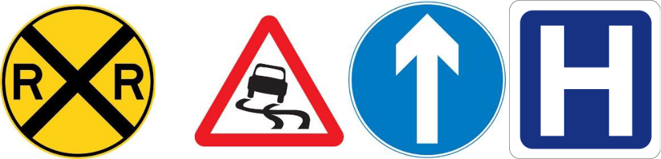

1.______________ 2._____________ 3._____________ 4._____________
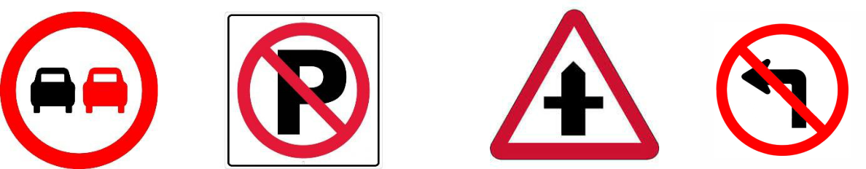

5.____________ 6._____________ 7.______________ 8._____________
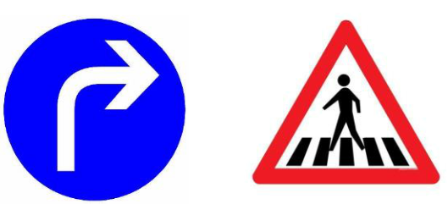

9.____________ 10.______________

III. Choose the best answer a, b, c or d to complete the sentence.

1. | You should walk across the street ______ the zebra crossing.
a. on |  | b. at | c. in | d. from
2. | My house is not far from my school, so I usually go ______.
a. on foot |  | b. by foot | c. by car | d. by boat
3. | This morning, I was ______ in a traffic jam and got to school fifteen minutes late.
a. catch |  | b. block | c. struck | d. stuck
4. | Turn on the left turn ______ before you make the turn and slow down.
a. sign |  | b. direction | c. signal | d. crossing
5. | It is ______ to use a hand-held mobile phone while driving or riding.

a. safe |  | b. important | c. illegal | d. careful
6. | ______ does it take you to ride to school? – About 30 minutes.
a. How long |  | b. How far | c. How often | d. How much
7. | A ______ is a part of a road that only bicycles are allowed to use.
a. cycle cross |  | b. cycle lane | c. cycle line | d. cycle race
8. | You ______ cross the street when the light is red.
a. should |  | b. don’t have to | c. can | d. mustn’t
9. | People ______ produce as much rubbish as we do now.
a. use to |  | b. used to | c. used to not | d. didn’t use to
10. “How far is Vung Tau from Ho Chi Minh City”-“_______”
A. It’s not very far |  | b. it takes about two hours or more.
c. It’s about 120km |  | d. You can get to Vung Tau by boat or bus.

VII. Match the questions with the correct answers.

1. | How does your father travel to word? | a. Oh, sorry sir, I don’t have it on me.
2. | May I see your driving license, please. | b. was stuck in a traffic jam.
3. | Sir, did I do anything wrong? | c. Not very far. Just about 2 km.
4. | What took you so long? | d. Go straight ahead, then turn right at the
 |  | crossroads.
5. | What is the fastest means of transport? | e. Yes, sir, You ran through the stop sign.
 |  | f. By motorbike.
6. | How far is it from here to the railway station?
7. | Could you tell me how to get to the nearest | g. Twenty minutes.
bus stop, please?
8. How long will it take to get there? |  | h. The plane, I think.

